Pre-requisites:

1. Make sure the vnet(site-to-site) is connected and active, and no restrictions are set between both endpoints.
2. Check Pinging to on-premises and on-premises to cloud using private IP address:
3. Go to Azure -> Create private DNS zones.

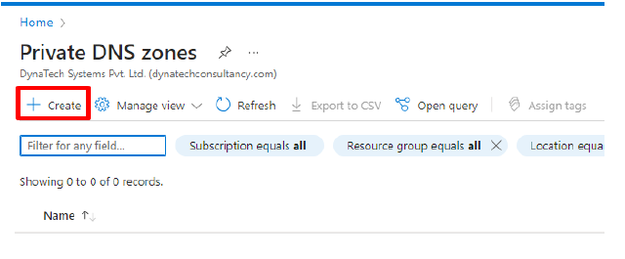

1. Select the Subscription, Resource Group, and Instance details name (it is your on prem Domain name).

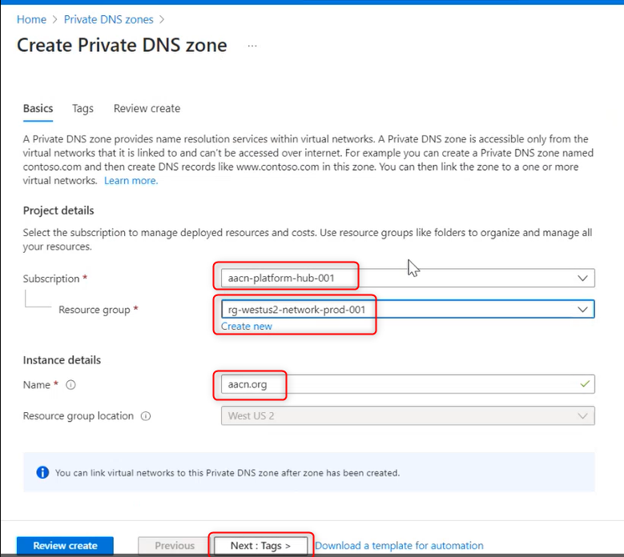

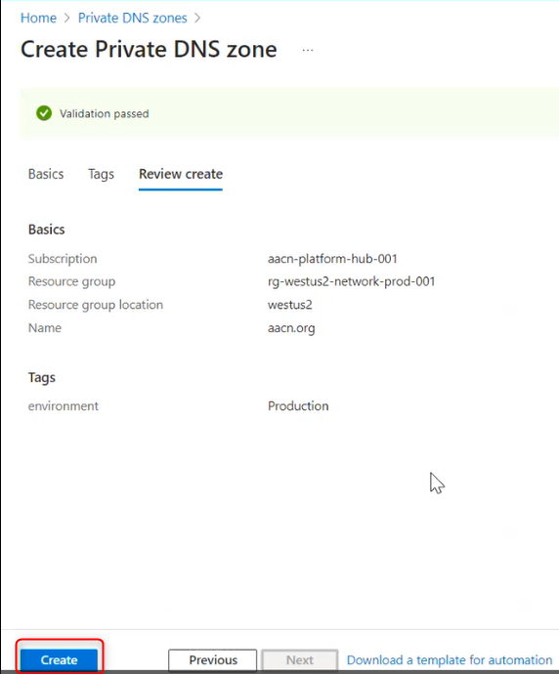

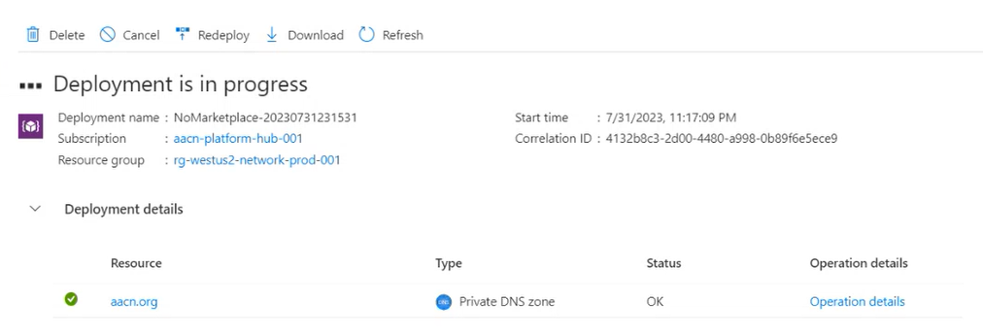

1. Go to Virtual network link and add:  
     
   A screenshot of a computer

   Description automatically generated

1. Go to on-premises AD and go to below path:

Run->”%SystemRoot%\System32\config”. Copy netlogon.dns file in your local system. Need to add those records in Azure Private DNS.

* These records are of global catlogs, forest, Domains, Kerberos, ldap purposes.

1. Add DNS Ips in virtual networks ->Custom DNS servers (public and Private):

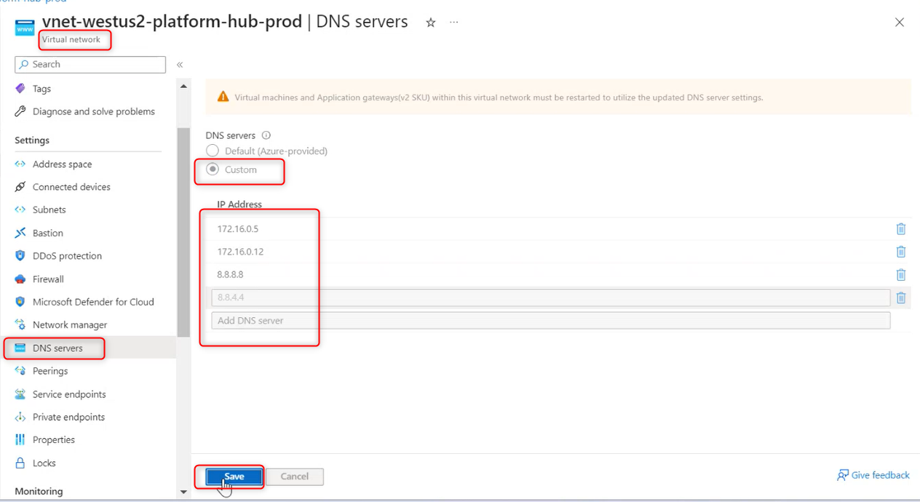

1. Restart the Azure VM:

*nslookup* should be your private DNS server IP and able to connect using DNS name:  
  
1. Add the Azure VM in LocalAD:

1. Restart the VM. Once, VM is restarted, make sure: Able to see azure VM DNS entry in Local DNS.